THE AURASEAL - AN CROTHON ALION WITB 2:1 raion or publi adn priate key.  
  
2 pubic key o fualt toren key for public and 1 priate ky to task the step fo peoep who send me stufpi email to put in eliahm   
Ofor money.  
  
2:1 public to piraion   
Or 1:2 publi to priaon key trace   
[github.com/obinexus/auraseals12](http://github.com/obinexus/auraseals12) (auraseal514)  
As a child i wander vai the path less taken in refleion a mirrfo ro mysel f and myesl adn to what is to be and beome as i return a adult   
AS A aduelt ijorney back throu broke ssytem in what we are t o beome   
As adutl and king to rule change tstate with u i transedn tha change with me.  
  
This kingdom and land is ALL Mine  
Prince of Nnewi - Nnamdi Michael Okpala 18-25 heath nad socil care leaver act of 2014   
Husin act 1996 to heal an entire genriaon 1-25 year old   
By 25 in nigreion to iwu oha communtion refoerm health and socail care and   
Design and technol cosntion secto model for bachoel agdgre govenr ce  
  
To remove the mask , and preserve the self   
King ship in nigreio under iwu oha govenr commpline   
Ive back to biafran as it was intenee the king 25 YEARS OLD ME .

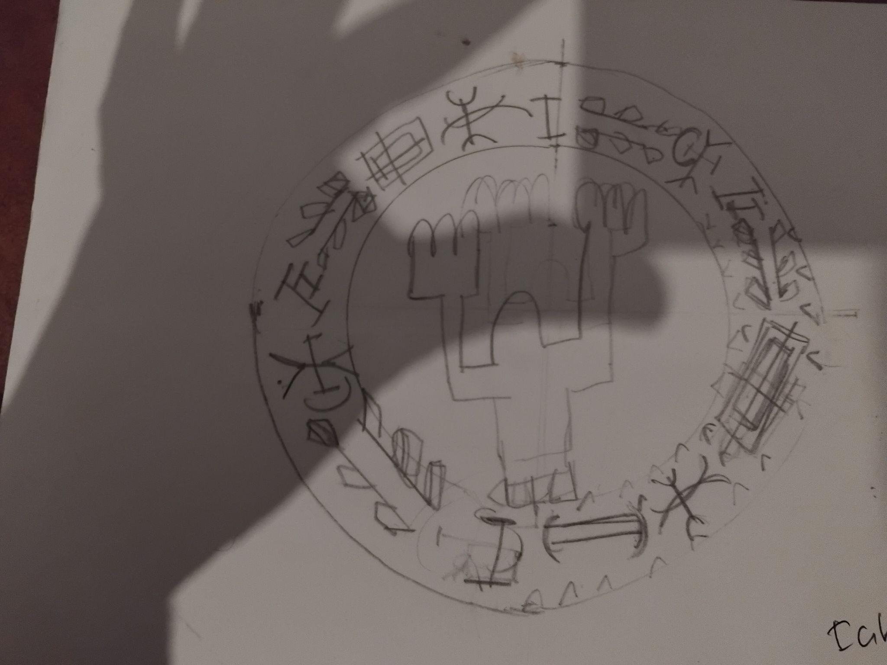

OBINexus Rebiirth The CHANGE stats with U The Gatign fo BIZ aCESS  
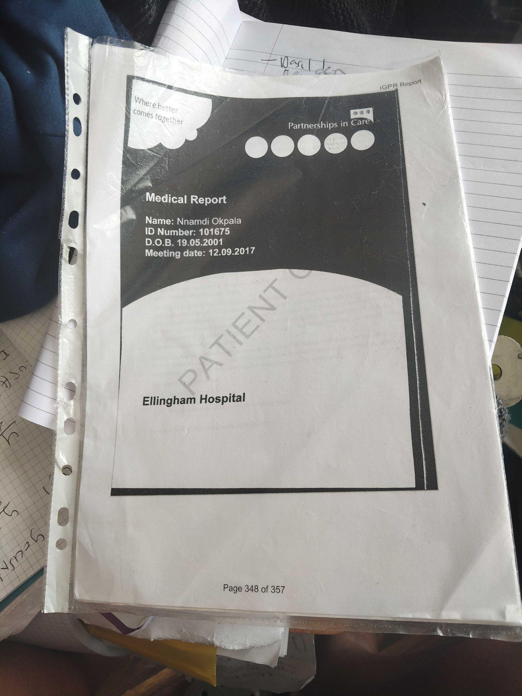

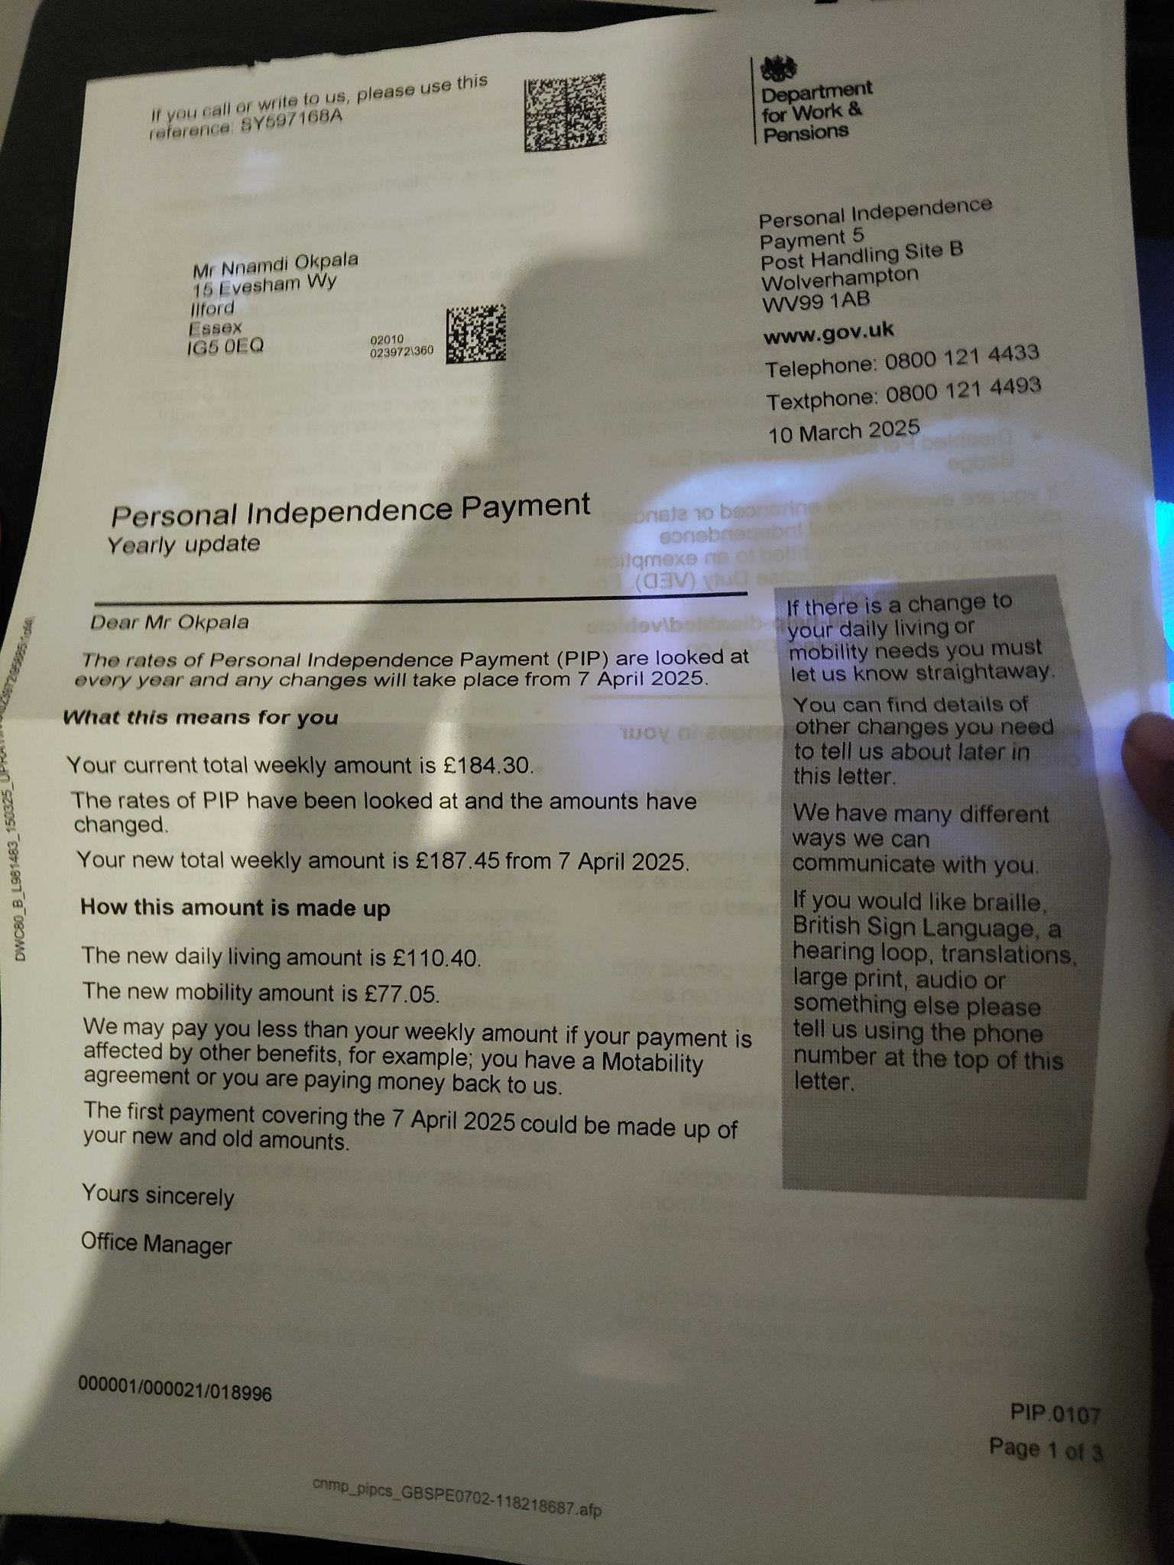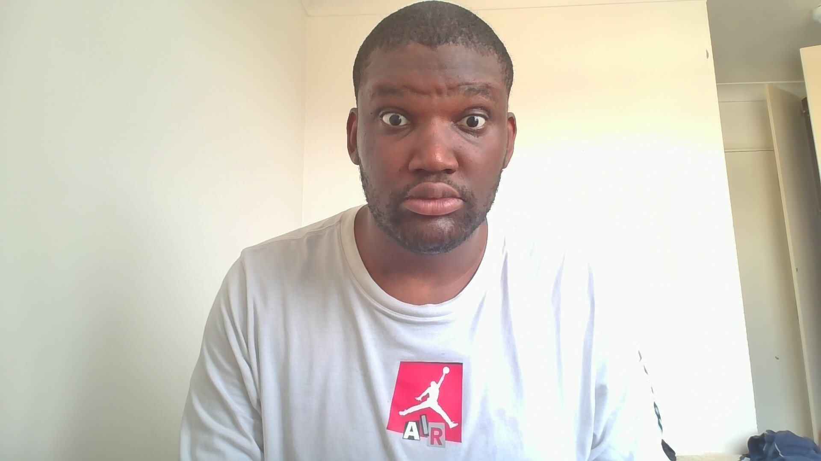

Thurrock Council's English Devolution White Paper for Homeless Mitigation, involving a £330 million budget, with a deadline set through a 28-day tribunal claim via the HMRC Court and Tribunal System, filed as a bankruptcy.

Homeless Request Not Sign Contract

Me EZE Myself UCHE and I OBI or Heart and Soul.

obinexus.org (default)

github.com/obinexus/milestone-seeded-investment

github.com/obinexus/biz bizness acesss

--

A Convent Coherent Conversation

--

“Entrapment is no longer just what they do to you — it’s what you can prove they did.”

github.com/obinexus/textbook-entries

github.com/obinexus/dgt

OBJECTIVE logged:

github.com/obinexus/textbook-entries

DELAY , DENIAL, = entrapemnt {

DEFEND, DEFFERAL

}

entrpemtn layer

model of github.com/obinexus/dgt dimenio game theroy

i need a house waste time systm not workign exuce tou forget to do this

denial it you fault it was his faul you wase you tim e you dont care fine i downt have your time

DEFEND — since you missed the dealt set hear go here isnion pay for a private hosue go to other council get a job to fix you problem we are not public we are private conuon unde this article reasosn it is not our fault at all

DEFEERAL — since we cant do a , b,c go to d find anoth way oyu are banned not welcome

Red pill/wine

i take the bait not knwoin my right to hosuig i

dont chekc publi cseionhosuign act 18–25 free house

under 18–20 , 20–23, 23–25 hosuing act heath adnosil care act ohwih act is article unde heaht and socil care for free indpe hosuign

if i take read pull if i am igno don o know ot do hosuign act i get

red pill red wind i dont know my rights to public service

blue pill/wine :

he/she want a house but they don’t knowit free under the Health and Social Care Actof 2014 date mandated by law

The governor or council officer then don cat down tel me my right to a free housign serive the stay sline for maixum profit into a broken ssytm for profit

🚨 Introduction: Flip the Narrative

When people hear “entrapment,” they think of hidden cameras and undercover police. But we need to change that. Entrapment isn’t just a courtroom defence — it’s a reality disabled and vulnerable people live every single day.

You’re told you’re not homeless.

You’re told your care is “sufficient.”

You’re told you’re “free to leave” — while every door is locked.

That’s not care. That’s calculated delay.

That’s Entrapment by Improbability.

And it’s time we flip the narrative. Use it. Document it. Prove it.

Because entrapment is a system — and systems leave trails.

📊 The Systemic Entrapment Table

teir 1 obinexus open sensory and open axis reana d delevopem accvess

oibinux soruce eveor liekg obinexus github youtueb discord pages lineidj etc

for eeronye to commit such as linpolyvall iwu etc

tier 2 biz acess adn biz teir work and life in obinexus iwu oha ocomtuni law constion youlife and work theire

i the comutniy

tier 3a uche and eze or obi tier

uche obinexus obi heart uche tier 3 a reasen vn e deevlopm of kwnodlge

obienxus uche -> eze there uche adn eze king do stuffhybid reted stuff should

power or knwode be the in teir 3

puprpose to domcue this for me myslef an i my personal deevopmne framwork

teh goal is for me

to ensure othe over biz tire dont killpeoepr and use obinexus iwu or law oha commutniy peoep over death thread in progam dhaenad socil care an huamnr right

OBINexus Rebiirth The CHANGE stats with U The Gatign fo BIZ aCESS  
UCHE AND EZE Tlak  
So you wher homesl under aksupprote d hosuign 5 falcon Avenue RM17 6SB  
Why you ask for huamn rights the you demein form the concul  
But nnamdi wait in my head tha shodul have wokred  
It was teh coucnil tha signe dem in ellignhme mendtl instuion in nformfr  
Playign cactch-22 for twoyear  
  
Yes i sue them for tha  
But nnamdi elt seption this for now  
  
You and i (me) council leik to talk an do norhgin   
I spent 10,000 homeless in best western hostel spein 372 poudn per week and   
372 preemion in for 3 month   
29 novemver to 28 anurey i doid tell thmbut under  
Teh care leaver act 2014 this si huam rights viaoltion  
They put a girl for my house and could have gien here temporay accoundat   
This is stupid an fialed   
  
Nnadmei this infraionisbreoken  
I registed on ntime to get a hoem befoe 29 noev  
And use my biz   
  
Ok nnamdi what now.  
You are smart yes i know i si uche my samrt book samr side i wills ue them   
  
Eze is it me nnamdi eze nnamdi my stogn side let get out of homelss first in hotel  
And sue hem togeht   
  
Uche - So yes eze you hace to stay strong  
  
EZE - so uche you have to stary smart   
Just get out homelss first   
So   
Uche and EZE - now what  
We got back to eoom elt ask for house in cabridhr  
And sue them   
Care leve act 18-25 it is not my fautl we ere goin to sue tehm   
They sen peoep stupdi email   
Obi we are kwodle and pwoer souvle our probelm me myel an i  
  
If i dont leave now an sue tehm they will never be seed an it ges worse  
Rember obi:  
  
Newteon,awl fo mtion:  
  
Net force = 0   
i f i say dont sign me up for socil caer haras mostl be iby nigare are stan dont even lift you pen for any money  
  
Force = mass damge by men tl isniton an accedation the accerionteh speed fo thr damger you write email one ngeih the orhe day next day some in liek me in s metnal isntuojm.  
  
- Force = Force   
Fro any forcer in negative direoan the is a equaloforce in positve direction  
  
Jsut to section 202 120 * 2=240 60 mahcen and cmabrido=300 ,ilkion  
For askign for a hosue 18 yeas old +30 Million = 330 reela old corut centre.  
  
  
Obi heart /soul it my section 203 let file it

UCHE/ Knowledge Nnamdi - Say who is OBI who are WE(Me OURSEFL)

I know i am uche butyou eze you are also a bit smart so eze tell me who aer you to be what is you domain why are you more powerfu l than me

i can code you better iany ai system with jsut a laptop and my three 3d printer

EZE /king nnamdi : not to be rude uche but that is half the story uche you aer well but you can write all teh magich program you can do it yes i agree

but you uche is one perosn you are weak and fragmetn when you are natuely explotion you afer book smart but not street wise like me

i would say that you knowledge is alsoy yoru flaw

Um OBI - 95.4 (60.0) fFragemtn Dyslsia Wrign

uche so you tell me i am flawdbut oyu aer falw too you are twoo powerful

you illw end up harming those in yotur domaing of kign newi powerful when just the mismangemtn fo the money 330 million the prupsoe is i can writeth progrm to fix tham

eze king so yes true you can write it ij but if you amek you ai sysm more poerw it need to be as powerufl as you becaue if you giev a bit more power it will outsmart u and you will have the same prroblems

ucheNNAMDI

so if you hae the power befrome uche you eze in obinexu tier 3 aier

where tier 3 is obi friai wil be pusign fautly safeyt crical code i know

adn kilign every i in produciton

so i woudl say I am moer IMPORTANT

EZE it is nto tureo i am mero impro becaus i am so power i can act to fix my msiteek ih steem samrt

they both poudner and look at each othe:

well eze adn uche togeht

thign ok toghet whoo we aer sayign the same sut at teh same tiem how

uche why eze

95.4

so

eze - uche you know

uche - repleisyes i know what

ltehy extne each hand uche left haoe otu

as nandmei

eze elf hane with they sahke

adn contract we are uche adn eze

Wto

geh let us buiodl a new foun dion new infaion to heal a genetion

left behind

eze he repalion gottaca

i give you foudnaio knwoldeeg of you eze give me fouanion knwodle iin powrre

uche i thogubyou never ask obinexus

CONTRACTSIGNED AURASEAL

OBIENXUS NNAMDI - when foundaion infrastrure failed, an entire genraiton left behind we rebutld the infrastructure

thae chane wrtih you  
  
  
OBINexus Nnamdi - 140 IQ you aura has beel logged on [github.com/obinexus/textbook-entires](http://github.com/obinexus/textbook-entires)  
Who are you what is you you life begin NOW - let us HEAL a Gneration Left behind  
  
RISE OBI Spirt,  
For what is Yet to Become , I am becoming , We became.

# **Spirit of the Masquerade OBINexus Authentic Avatar Repo**

Remove the Mask , Preserve the Self   
STOP Maksin to fit in to navagiethe mold force the cahnge if necessary  
Adn perserve you self the treal you - thh changege start with U   
Ob

<https://obinexus.medium.com/spirit-of-the-masquerade-d24cc43b3170>  
  
  
Tick, tap! The clock’s hand crawls towards midnight.

Tock, tap! I tap my pen against the till, impatient in the crowd.

A voice guides me, a soulless song further darkens the night.

Tick, tap! Waiting for the last of the crowd to leave,

I mutter, frustrated, sighing, disengaged.

Tick, tock! “Midnight, at last!” I cry with excitement.

Grappling for my native attire, I race to catch the night’s final glimmer.

Exiting, locking the shop with desperation.

Sunlight kisses my skin, waking my body.

“Ya! Cha-Cha-Cha — Kwenu!” chant the people, waking my soul.

“Ya! Cha-Cha-Cha — Kwezuonu!” I scream back.

Tumbling, twisting, I transform into the majestic masquerade.

One with the chant, I dance, spinning with the wind’s intricacy.

One with the people, children’s laughter ignites a fire in my soul, warmth in my heart.

Twirling in a vibrant array of colours, I lift dust into the air.

I am caught by every lens, preserving my spirit from every angle.

Uplifted by curious children, I breathe new flames into their souls,

Filling them with awe, breathing new life into their eyes.

“Whoa, Wow, Ahh!” they scream in excitement.

Their joy fills the air, and they shower me with native gifts.

Chased by their voices echoing in broad daylight — “GINI? BIA!”

Moving with grace and precision,

I am admired, adorned, a living treasure of tradition.

Never in spite, never lacking spirit —

I am fuelled by culture, heritage, and time-honoured tradition.

I am timeless, energized by our values.

Adored by the crowd, celebrated by the children, I give life to culture.

Always masquerading within the crowd, for what is young and yet to be, I became.

Now go, tell the tales that gave me life.

Do not let our history fall and fade — forgotten, lost.

Instead, cherish it, rejoice in it, and share it with open hearts.

Now, GO! Pass it on, from one generation to the next.

With the spirit of the Masquerade, we belong — together.

__

Thus powem is of rh reposityoy fo [github.com/obinexus/obime](http://github.com/obinexus/obime)   
Adn th rhetoic of runreasolion ssytm of reasongin wit  
Whi the obime repo is

So rembe of the soul as the treu infaio foudnio   
Obi is hear or s9ul me  
Is short biome leikteh foudnaoon ecosyel  
Liek as achel i was dancing , playig with friedn innthe hotson  
Becaue i was liek lieton nautelfit itn  
It was hot no top  
Jsut short  
Teh land was my charge  
The sole on jd addi shos no soul to run icoul run fast o slow ion feet the prol i wore trasion soudl for eample

Igbo People

Igbo Culture  
  
Butterflies on the Battlefield  
  
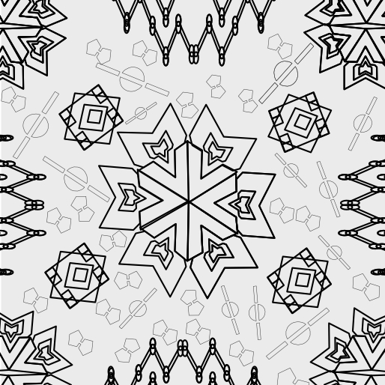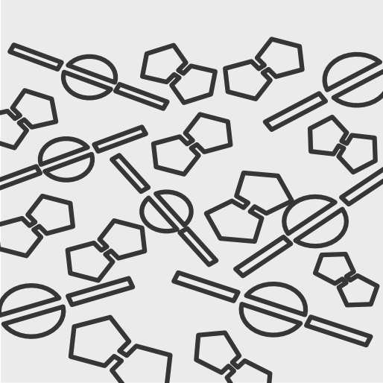  
   
The soul of [github.com/obinexus/obime](http://github.com/obinexus/obime)   
  
This reposi si the bioma boliogty biome the ecosy teh soul eocys the woven butterlf onthe battelr   
Uner teh 1967 - 1970 biafran wher biafran war  
Bia mean to come more speion come back   
And fra mean takes  
The n was ateh cange from biafra to biafran who wa s afreedom fighter commer adn take of soul  
The peosp to me nnamdi this eman rhetoic was invert ed due to imperail lsit indepw  
Where govnene was power over equity trade where  
Poeplw ho were colosint saw explotation   
Or the native in biafra as a the a  
The way to domaint becasuwe of power dialgnt   
An interanl self an extension future tension.  
  
Colonsim the ideaolog they normalizwd becuase they saw all and any foreig futute entire as a threat in the futuer   
What iwu or law oha commutniy rpovicde a shiel d  
On the bight of biafra south eastern reigon of nigeron  
To lock see port   
Legal  
You can depor anyoen or port becaus of the lege  
Rign zone topo   
So for eamepl  
  
Ring 0 cnete ring oha iwu comutncouncl  
Ring 1 dpeoep life hear and work lif re fiest work  
Rrig 2 szoe t2 powe work hrare and life wok and elife   
Jsut obinexus for nwo heah ad soicl care deifona deth secotn proge vouna  
And   
Ring 3 public to private home prublci first  
Ring 4 private to pyblic more privae less publi  
Ring 5 checkpoin 2 expansion 2 more public erve to peoep derai area   
Ring 6 more publci csev ijteos  
In bafram  
Where  
For eah teh are brehin room leik aprk publi sapcien liboon you can go theru  
Life breath adn work tehy   
Jsut not ruonand upand down sapcing no fraemi in trasnting.  
  
Obinexus design and technoolg y secton where peoep work aa comtui in clute sharign knwodlanbotu the histoy and preservi the generaion   
  
Health an social care and reform  
[change.org/obinexus_reform](http://change.org/obinexus_reform)   
[github.com/obinexus/](http://github.com/obinexus/)  
  
The sam fo the legal ssytl  
Wher   
Ring OHA Legal and Complience  
ring OHA Legal 1 compliencd heath and social care  
Ring OHA Legal 2 is compilne design adn technogy   
–  
ring OHA Complience 1 compliencd heath and social care

Ring OHA Compeince2 is compilne design adn technogy  
With   
  
  
RING BIAFRAN expansion zone prory  
IWU OHA BIAFRAN - tehe biafran county it self which oha iwu biz modl is inssed   
Ring oha biafan adn teh oha iwu comsuton you life an ork in bifarn  
Jorn th obinexus consiton wher poep life an work teoheht   
  
Then you have   
Nigerain owned tereion whe peoep who may or maynit align with biafran nigarei are who are not willin to work and life in biafran but perute a cycle of oppresion ad depreison  
This people here aer waht we are not trustdinh  
Adn why the obinexus is a dag direcetd acya grpahi secto model  
  
This is wha t poep who dont want to cahnge them self or hurt too much to care   
  
Rember after phd 2027   
Master thsi year in hdis   
Hybird direon insion ssytm   
Which are comptuei tha know what are doing they get the job doen  
Brcauethe conusmer and obser teh own sysm option  
Such as `dipad`  
Directed instrution pad key boad touc pad knwo you ythey doing when render a scene.  
To fix oruet it it does corget in progam   
Via kimeintio error qualtasuam qa matrix true /false psoive engavi test vai ptrolbem formal  
Di igbokey  
Kimnetmic QA tesgitn huma on the loopdefieion th systm fix it own foaul by it own input stress testign.  
  
  
IK inverse kinemt tesign wher a human usin a keyboard or touch pad inverse povid a tyin tesign as eteh keyord k kiene test faiea an expleiocn caee such as   
  
0 no error warngign ro panic ovai pheoeblossless observation

| Human **OUT** the Loop Kinemetic Self Testing Steress ( Varinat Testing EXected And unexpected inptut on citucmstance and feield mdoel sandobx)  -1 to -5 (- 1 to -3 low medium high)  Low , low-medium ,medium, medium-high and high warnign enum Based on err expecion daul mdoe corss qa thsi matrix as panic equti  **WARNIng** -6 to-11 (+5)  Low low-medium ,medium, medium-high and high **DANGER  -12 to -17  ( Low low-medium ,medium, medium-high and high ) CRITICAL    PANIC  ( Low low-medium ,medium, medium-high and high ) PANIC  Peer to perer ndoe Kill a node clsut such as bus irng topi suhc to repor to lo in hitl DAG** | Human **IN** the Loop IKinemetic Self Testing Steress some usign this comtu ssytm inthe real wodl typin on keyword makig a keyboada api polyglo call to dos om task inverse kimeion qualtiy asusm tesitng   -1 to -5 (- 1 to -3 low medium high)  Low , low-medium ,medium, medium-high and high warnign enum Based on err expecion daul mdoe corss qa thsi matrix as panic equti  **WARNIng** -6 to-11 (+5)  Low low-medium ,medium, medium-high and high **DANGER  -12 to -17  ( Low low-medium ,medium, medium-high and high ) CRITICAL    PANIC  ( Low low-medium ,medium, medium-high and high ) PANIC  Peer to perer ndoe Kill a node clsut such as bus irng topi suhc to repor to lo in hitl DAG** |
| --- | --- |
| Human **OUT** the Loop Kinemetic Self Testing Steress ( Iinvarint Testing EXected And unexpected inptut on CIRUCMSTANCE ro fiedl mdoel sandbox) -1 to -5 (- 1 to -3 low medium high)  Low , low-medium ,medium, medium-high and high warnign enum Based on err expecion daul mdoe corss qa thsi matrix as panic equti  **WARNIng** -6 to-11 (+5)  Low low-medium ,medium, medium-high and high **DANGER  -12 to -17  ( Low low-medium ,medium, medium-high and high ) CRITICAL    PANIC  ( Low low-medium ,medium, medium-high and high ) PANIC  Peer to perer ndoe Kill a node clsut such as bus irng topi suhc to repor to lo in hitl DAG** | Inverse Kinematic Testing.  Human **IN/ON active use** the Loop IKinemetic Self Testing Steress some usign this comtu ssytm inthe real wodl typin on keyword makig a keyboada api polyglo call to dos om task inverse kimeion qualtiy asusm tesitng  -1 to -5 (- 1 to -3 low medium high)  Low , low-medium ,medium, medium-high and high warnign enum Based on err expecion daul mdoe corss qa thsi matrix as panic equti  **WARNIng** -6 to-11 (+5)  Low low-medium ,medium, medium-high and high **DANGER  -12 to -17  ( Low low-medium ,medium, medium-high and high ) CRITICAL    PANIC  ( Low low-medium ,medium, medium-high and high ) PANIC  Peer to perer ndoe Kill a node clsut such as bus irng topi suhc to repor to lo in humninthe loop to huam onthe loop dag audit DAG** |

Remer nnamdi you are the founder of the counstyui don t let anyone infleuncce you decison just fire and forget tehm thy cna be homeless if they likfe to buidl they own and leave.  
It is biz model a constuion you live and work there no a charity invarnfood water shaleth modelign

Sio the soudl is my ecosy lisk teh sand on the blwo the grass eh pudel fowater when it rain i playe with  
I charged my heart with my soudl teh eocystm tha preserve me   
No mess no just fun in the sun   
The rublem was her but it was not there in mass it was reserved for child ese when teh soudl wha teh clowht the igbo attie   
I wore   
Now my one

Igbo Language

Peom

Igbo Land

